TASK-1
Aim: To write digitSum opt (sum of even or odd digits).
Algorithm:
- Start.
- Initialize a variable sum to 0.
- Repeat the following steps while input1 is greater than 0:
- Extract the last digit using d = input1 % 10
- If input2 is "even" and d is an even number, add d to sum
- If input2 is "odd" and d is an odd number, add d to sum
- Remove the last digit from input1 using input1 = input1 / 10.
- After the loop ends, return the value of sum.
- Stop.
Program:
public int EvenOddDigitsSum(int input1, String input2) {
int sum = 0;
while (input1 > 0) {
int d = input1 % 10;
if (input2.equals("even") && d % 2 == 0) sum += d;
if (input2.equals("odd") && d % 2 != 0) sum += d;
input1 /= 10;
}
return sum;
}
public static void main(String[] args) {
Task1 task = new Task1();
System.out.println(task.EvenOddDigitsSum(12345, "even")); // Expected: 6
System.out.println(task.EvenOddDigitsSum(12345, "odd")); // Expected: 9
}
}
Out Put:
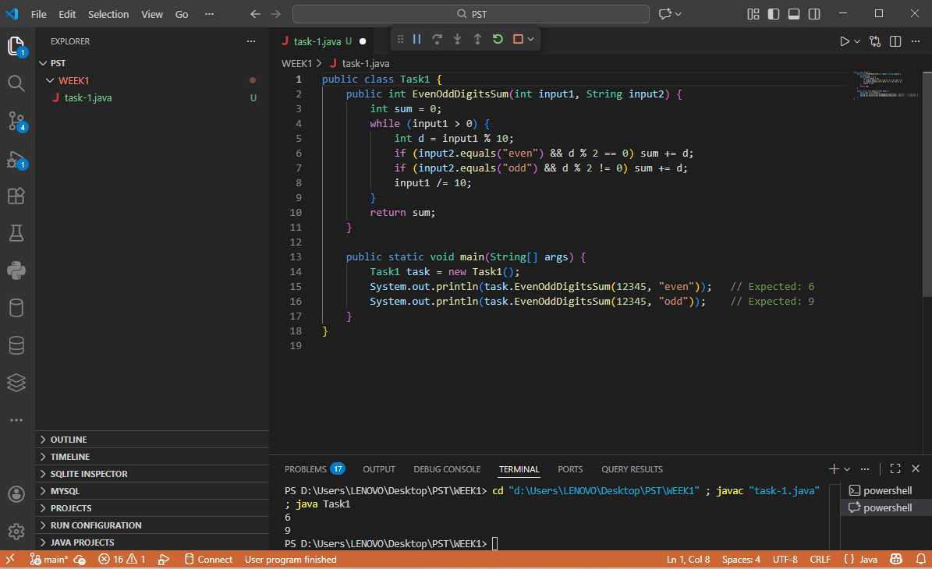
TASK-2
Aim: To find the Nth Fibonacci number using an iterative approach.
Algorithm:
1) Start
2) Initialize variables:
- a = 0 (first Fibonacci number)
- b = 1 (second Fibonacci number)
- c = 0 (to store next Fibonacci number)
- d = 3 (counter starting from the 3rd position)
3) If input1 is 1, return 0
4) If input1 is 2, return 1
5) While d is less than or equal to input1, repeat:
- Calculate next Fibonacci number: c = a + b
- Update values:a = b,b = c
- Increment counter d by 1
6) After the loop ends, return c as the Nth Fibonacci number
7) Stop.
Program:
class UserMainCode
{
public long nthFibonacci(int input1){
if(input1 <= 0) return 0;
if(input1 == 1) return 0;
if(input1 == 2) return 1;
int a = 0;
int b = 1;
int c = 0;
for(int i = 3; i <= input1; i++){
c = a + b;
a = b;
b = c;
}
return c;
}
public static void main(String[] args) {
UserMainCode obj = new UserMainCode();
System.out.println(obj.nthFibonacci(1)); // 0
System.out.println(obj.nthFibonacci(2)); // 1
System.out.println(obj.nthFibonacci(5)); // 3
System.out.println(obj.nthFibonacci(10)); // 34
}
}
OutPut:
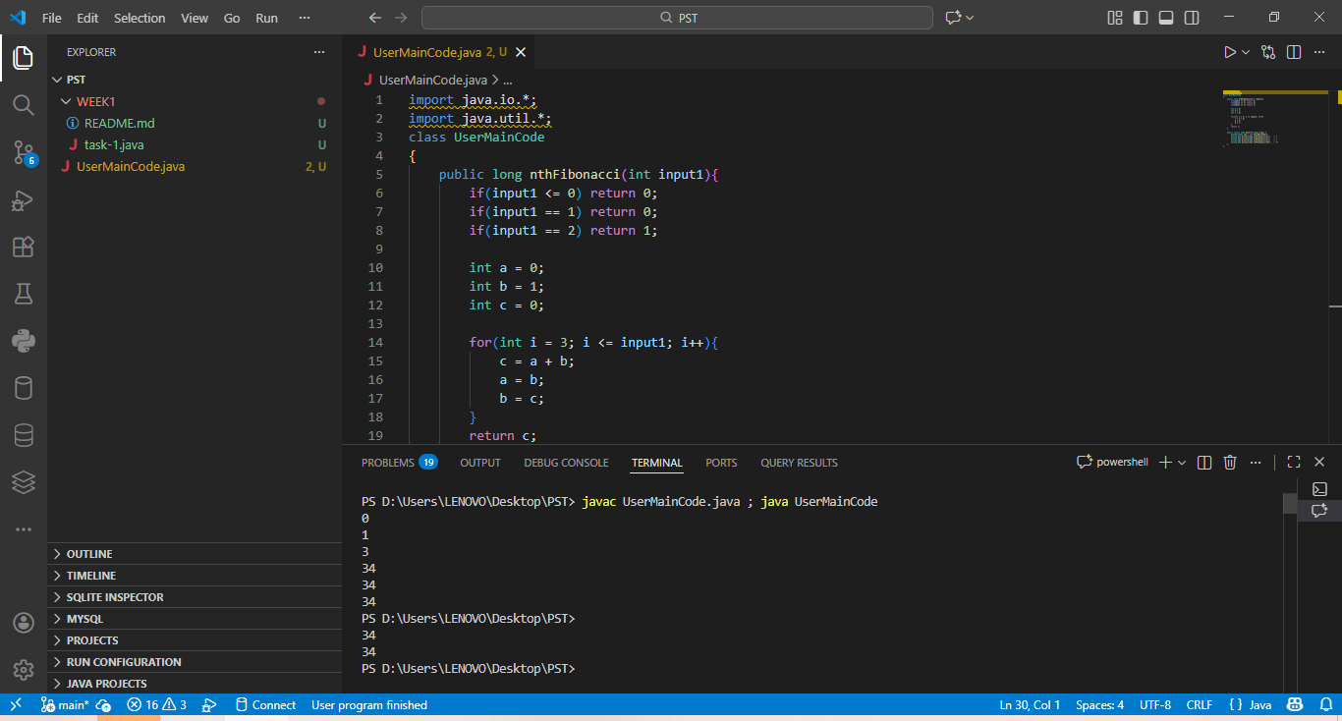

TASK-3
Aim: To check whether a given number is a palindrome number and return.
Algorithm:
1) Start
2) Store the input number in a temporary variable temp
3) Initialize rev to 0
4) While input1 is greater than 0, repeat:
- Get the last digit using input1 % 10
- Add the digit to the reversed number:
- rev = rev * 10 + (input1 % 10)
- Remove the last digit using input1 = input1 / 10
5) After the loop ends, compare rev with temp
6) If rev is equal to temp, return 1
7) Otherwise, return 2
8) Stop.
Prrogram:
class Task3 {
int isPalinNum(int input1) {
int temp = input1;
int rev = 0;
while(input1 > 0) {
rev = rev * 10 + input1 % 10;
input1 /= 10;
}
if(rev == temp) return 1;
return 2;
}
public static void main(String[] args) {
Task3 obj = new Task3();
System.out.println(obj.isPalinNum(121));
System.out.println(obj.isPalinNum(12321));
System.out.println(obj.isPalinNum(123));
System.out.println(obj.isPalinNum(1001));
}
}
OutPut:
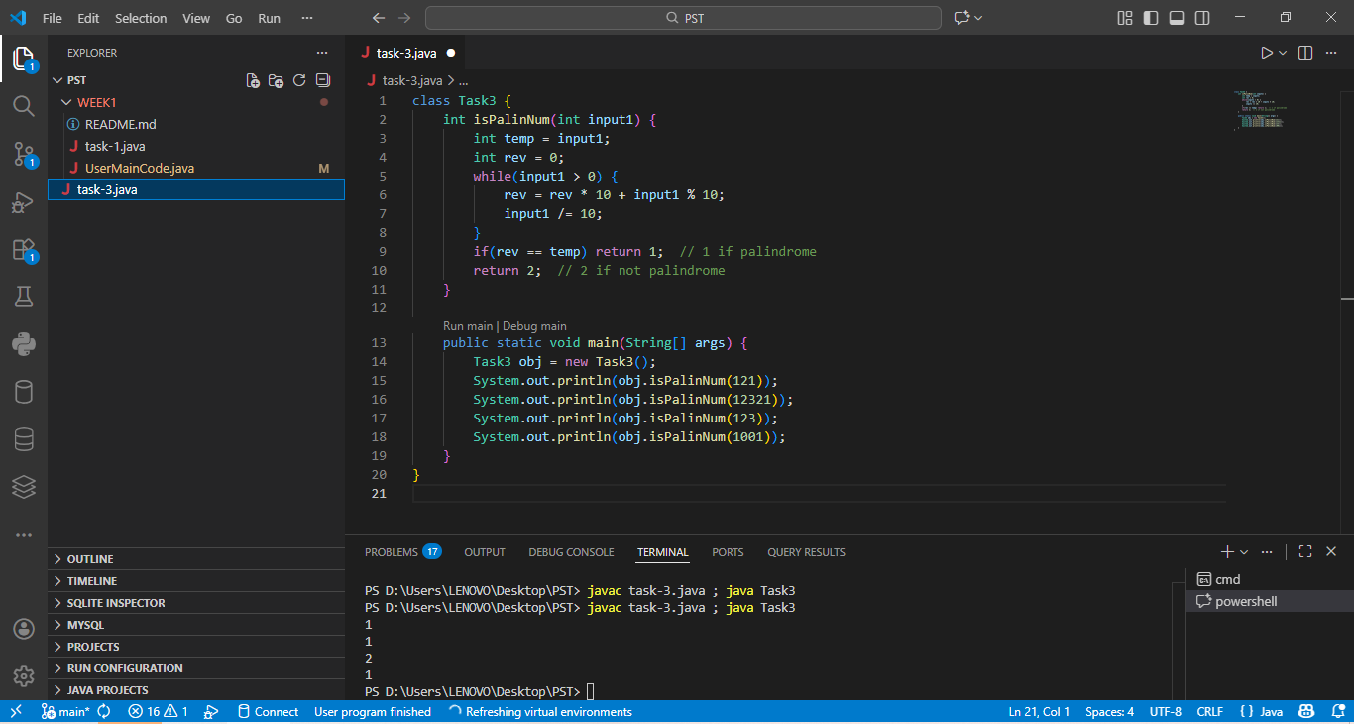

TASK-4

Aim: To find the sum of the last digits of two given numbers, considering both positive and negative integers.
Algorithm:
1) Start
2) If input1 is a negative number, convert it to positive
3) If input2 is a negative number, convert it to positive
4) Find the last digit of input1 using input1 % 10
5) Find the last digit of input2 using input2 % 10
6) Add the two last digits
7) Return the sum
8) Stop.
Program:
class UserMainCode
{
public int addLastDigits(int input1, int input2) {
if(input1 < 0)
input1 = (-1) * input1;
if(input2 < 0)
input2 = (-1) * input2;
return (input1 % 10) + (input2 % 10);
}
public static void main(String[] args) {
UserMainCode obj = new UserMainCode();
System.out.println(obj.addLastDigits(123, 456)); // 3 + 6 = 9
System.out.println(obj.addLastDigits(-123, 456)); // 3 + 6 = 9
System.out.println(obj.addLastDigits(100, 200)); // 0 + 0 = 0
System.out.println(obj.addLastDigits(789, -321)); // 9 + 1 = 10
}
}

OutPut:
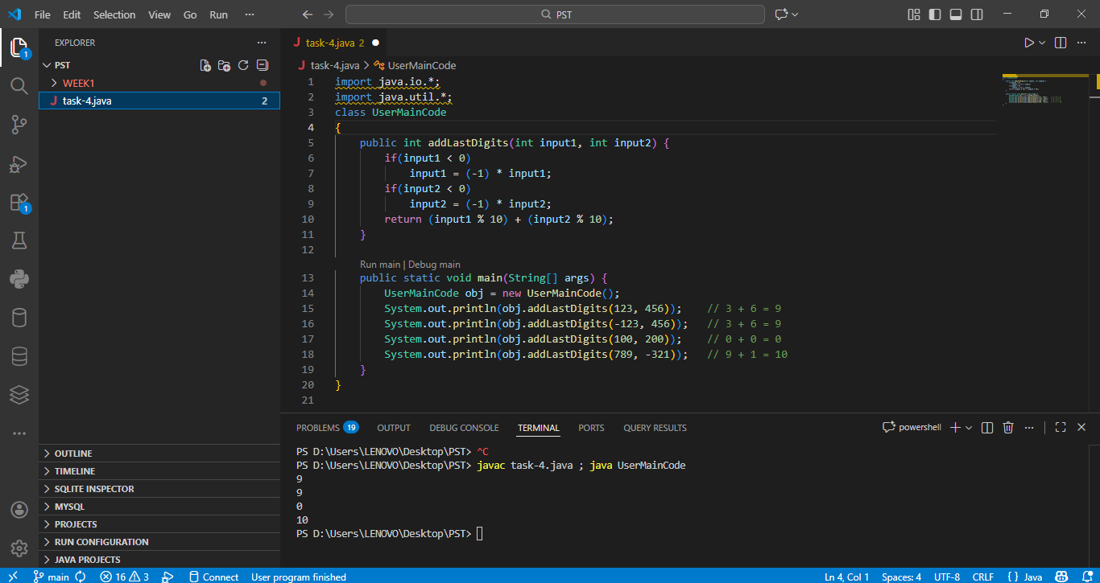

TASK-5
Aim: To count the number of prime numbers within a given range of integers and display the prime numbers in that range.
Algorithm:
1) Start
2) Initialize:
- d = input1 (current number)
- cou = 0 (to count prime numbers)
3) While d is less than or equal to input2, repeat:
- Initialize c = 0 (to count divisors)
- For i from 2 to d - 1:
- If d is divisible by i, increment c
- If c is equal to 0, then:
- d is a prime number
- Increment cou
- Display the value of d
- Increment d by 1
4) After the loop ends, return cou
5) Stop.
Program:
public class UserMainCode
{
public int countPrimesInRange(int input1,int input2){
int d=input1,i,c=0;
int cou=0;
while(d<=input2){
for(i=2;i<d;i++){
if(d%i==0){
c++;
}
}
if(c==0){
cou++;
System.out.println(d);
}
d++;
c=0;
}
return cou;
}
public static void main(String[] args){
UserMainCode obj = new UserMainCode();
System.out.println("Count of primes between 1 and 20: " + obj.countPrimesInRange(1, 20));
System.out.println("Count of primes between10 and 30: " + obj.countPrimesInRange(10,30));
}
}
OutPut:
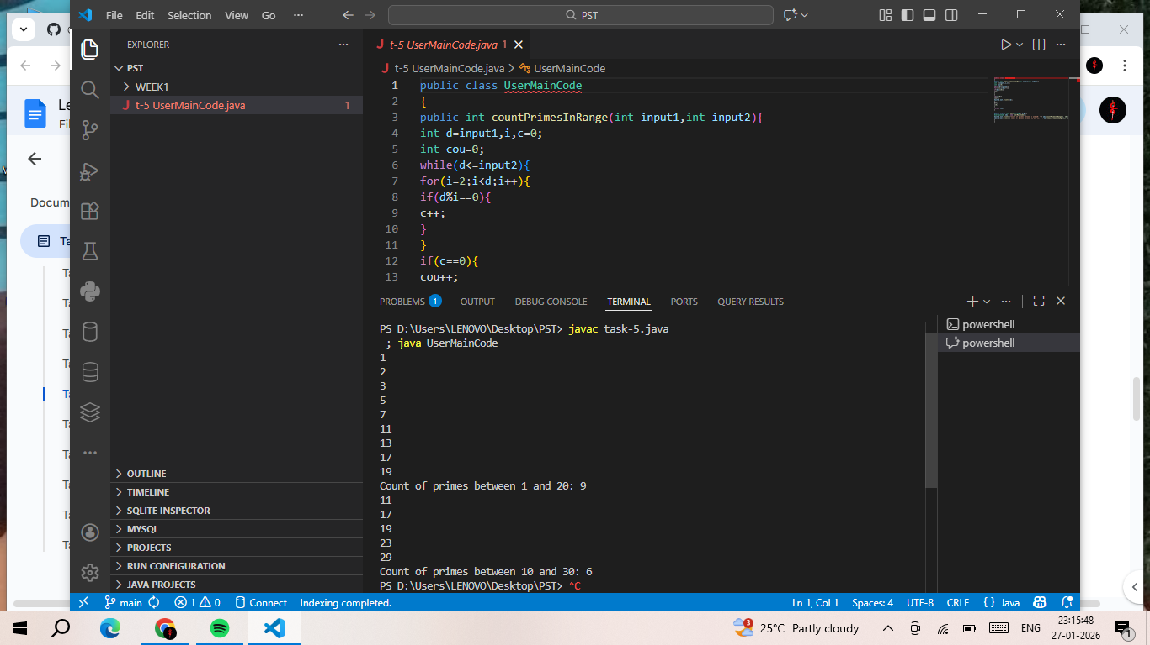

TASK-6
Aim: To calculate the sum of the digits of a number raised to the power of the total number of digits in the given number.
Algorithm:
1) Start
2) Store the input number n in a temporary variable temp
3) Initialize sum to 0
4) Find the total number of digits in n and store it in digits
5) While temp is greater than 0, repeat:
- Extract the last digit using d = temp % 10
- Calculate the power of the digit: d ^ digits
- Add the result to sum
6) Remove the last digit using temp = temp / 10
7) After the loop ends, return the value of sum
8) Stop.

Program:
public class Task6 {
static int sumOfPowerDigits(int n) {
int temp = n, sum = 0;
int digits = String.valueOf(n).length();
while (temp > 0) {
int d = temp % 10;
sum += Math.pow(d, digits);
temp /= 10;
}
return sum;
}
public static void main(String[] args) {
System.out.println("Sum of power digits of 153: " + sumOfPowerDigits(153));
System.out.println("Sum of power digits of 370: " + sumOfPowerDigits(370));
System.out.println("Sum of power digits of 9474: " + sumOfPowerDigits(9474));
}
}
OutPut:
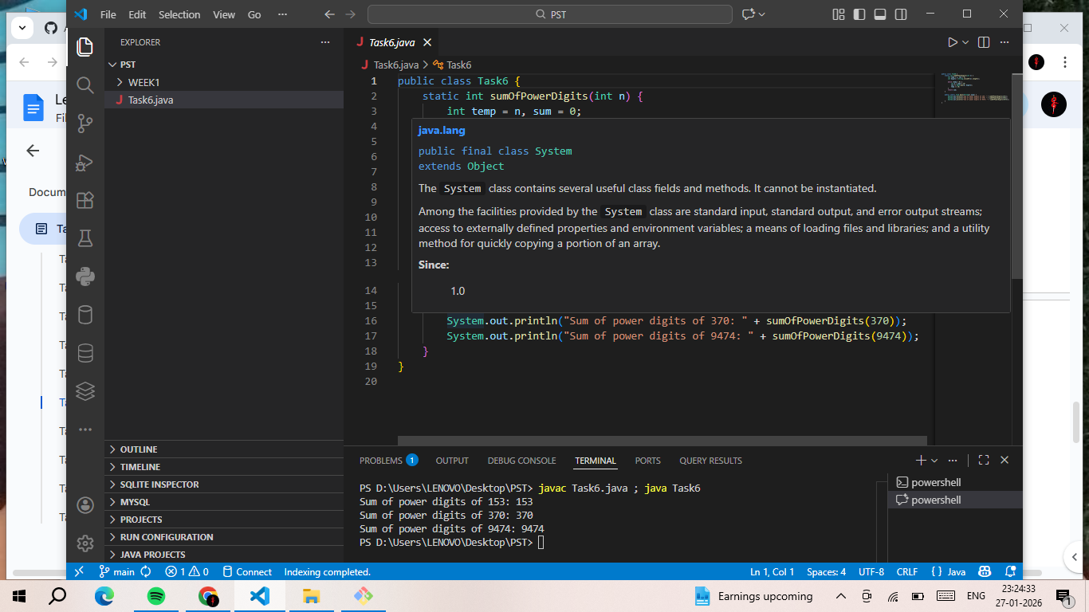

TASK-7
Aim: To find the count of unique digits present in a given integer number.
Algorithm:
1) Start
2) Create a boolean array seen[10] and initialize all values to false
3) Initialize a variable count to 0
4) While n is greater than 0, repeat:
- Extract the last digit using d = n % 10
- If seen[d] is false, then:
- Mark seen[d] as true
- Increment count by 1
- Remove the last digit using n = n / 10
5) After the loop ends, return the value of count
6) Stop.
Program:
public class Task7 {
static int uniqueDigitCount(int n) {
boolean[] seen = new boolean[10];
int count = 0;
while (n > 0) {
int d = n % 10;
if (!seen[d]) {
seen[d] = true;
count++;
}
n /= 10;
}
return count;
}

public static void main(String[] args) {
System.out.println("Unique digits in 12321: " + uniqueDigitCount(12321));
System.out.println("Unique digits in 111: " + uniqueDigitCount(111));
System.out.println("Unique digits in 123456789: " + uniqueDigitCount(123456789));
System.out.println("Unique digits in 1000: " + uniqueDigitCount(1000));
}
}
Out Put:
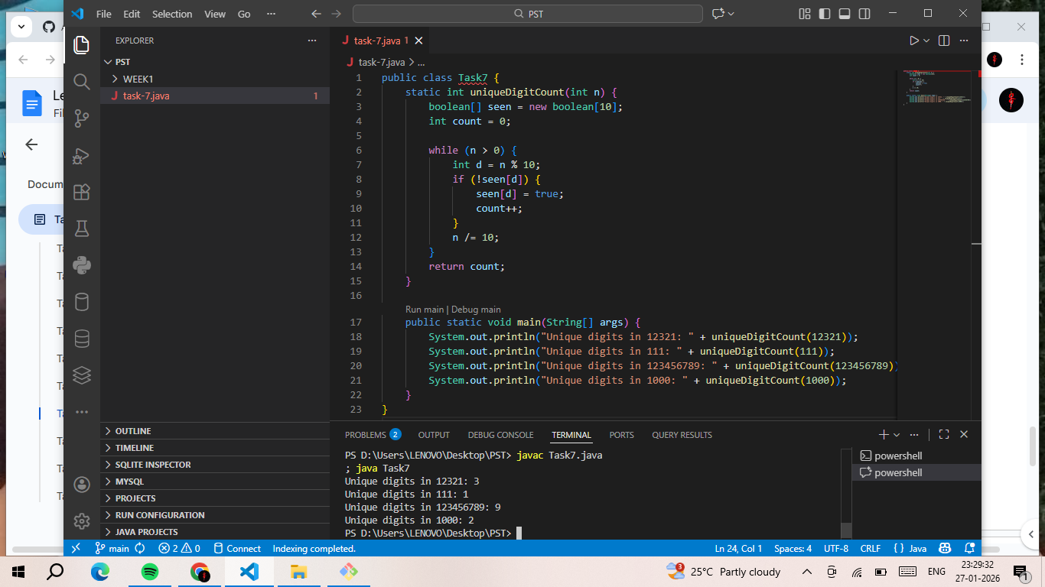

TASK-8
Aim : To find the count of unique digits present in a given integer number.
Algorithm:
1) Start
2) Create an integer array freq[10] and initialize all values to 0
3) While n is greater than 0, repeat:
- Extract the last digit using n % 10
- Increment the frequency of that digit in the array
- freq[digit] = freq[digit] + 1
- Remove the last digit using n = n / 10
4) Initialize max = 0 and digit = 0
5) Traverse the frequency array from index 0 to 9:
- If freq[i] is greater than max, update:
- max = freq[i]
- digit = i
6) After the loop ends, return digit as the most frequent digit
7) Stop.
Program:
public class Task8 {
static int most Frequent Digit (int n) {
int [] freq = new int [10];
while (n > 0) {
freq[n % 10]++;
n /= 10;
}
int max = 0, digit = 0;
for (int i = 0; i < 10; i++) {
if (freq[i] > max) {
max = freq[i];
digit = i;
}
}
return digit;
}
public static void main(String[] args) {
System.out.println("Most frequent digit in 112233: " + mostFrequentDigit(112233));
System.out.println("Most frequent digit in 111222333: " + mostFrequentDigit(111222333));
System.out.println("Most frequent digit in 987654321: " + mostFrequentDigit(987654321));
System.out.println("Most frequent digit in 555: " + mostFrequentDigit(555));
}
}
Out Put:
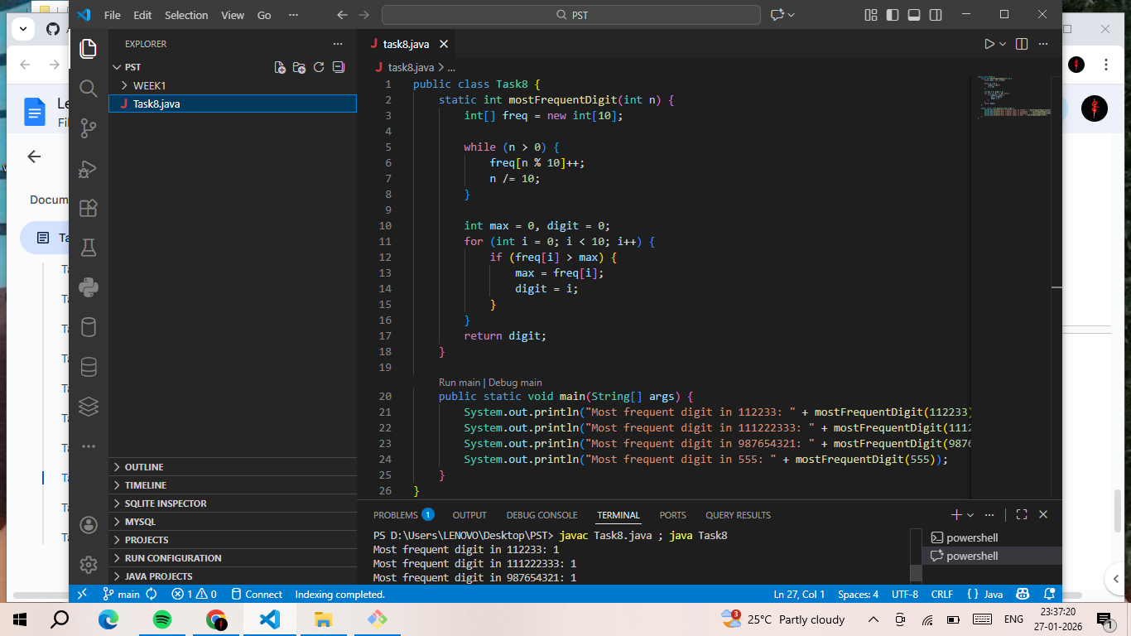

TASK-9
Aim : To calculate the sum of array elements located at non-prime index positions.
Algorithm:
- Start
- Define a function isPrime(n) to check whether a given index n is a prime number:
- If n is less than 2, return false
- For i from 2 to √n:
- If n is divisible by i, return false
- Otherwise, return true
- Initialize a variable sum to 0
- Traverse the array using index i from 0 to arr.length − 1:
- If i is not a prime number, add arr[i] to sum
- After completing the loop, return the value of sum
- Stop.
Program:
public class Task9 {
static boolean isPrime(int n) {
if (n < 2) return false;
for (int i = 2; i * i <= n; i++) {
if (n % i == 0) return false;
}
return true;
}
static int sumNonPrimeIndex(int[] arr) {
int sum = 0;
for (int i = 0; i < arr.length; i++) {
if (!isPrime(i)) sum += arr[i];
}
return sum;
}
public static void main(String[] args) {
int[] arr1 = {10, 20, 30, 40, 50, 60};
System.out.println("Array: [10, 20, 30, 40, 50, 60]");
System.out.println("Sum of elements at non-prime indices: " + sumNonPrimeIndex(arr1));
int[] arr2 = {1, 2, 3, 4, 5, 6, 7, 8, 9, 10};
System.out.println("\nArray: [1, 2, 3, 4, 5, 6, 7, 8, 9, 10]");
System.out.println("Sum of elements at non-prime indices: " + sumNonPrimeIndex(arr2));
}
}
OutPut:
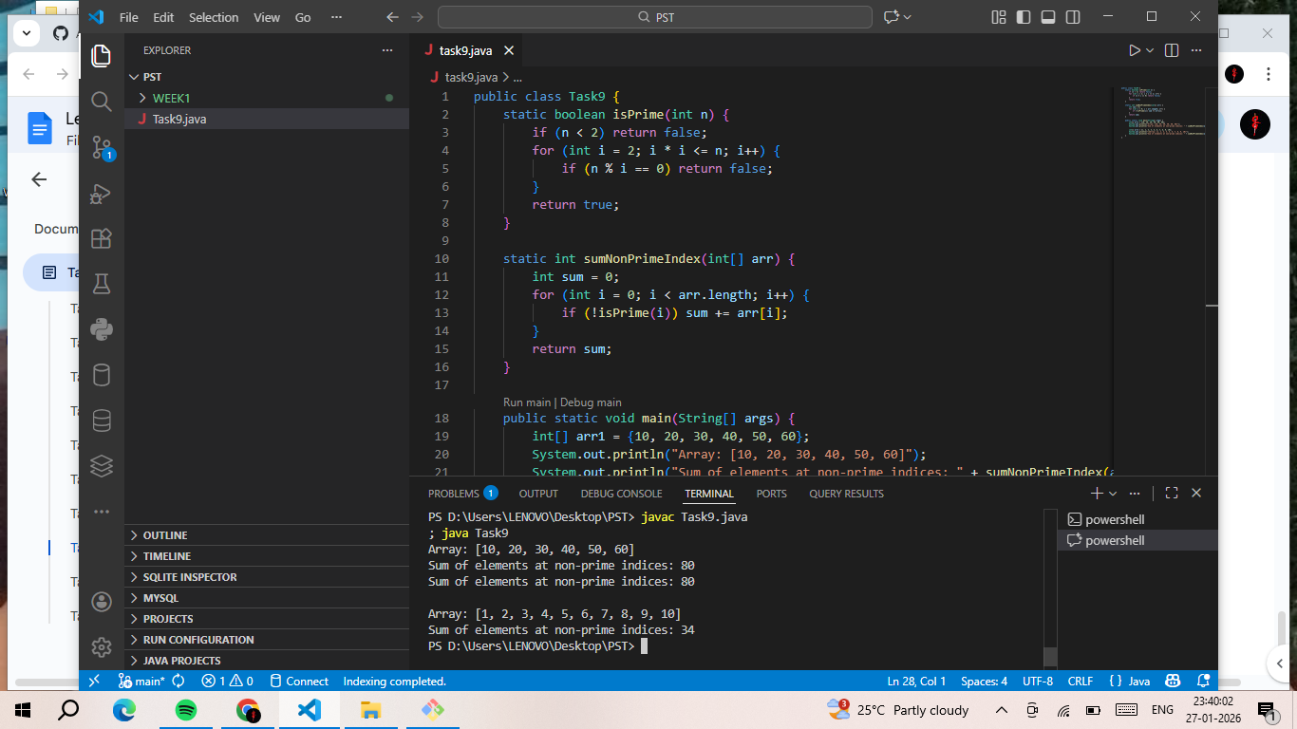

TASK-10
Aim: To return the second word of a given string in uppercase.
Algorithm:
- Start
- Split the input string str into words using space as the delimiter
- Store the words in a string array words
- If the number of words is less than 2, return "LESS"
- Otherwise, convert the second word (words[1]) to uppercase
- Return the uppercase second word
- Stop.
Program:
public class Task10 {
static String secondWordUpper(String str) {
String[] words = str.split(" ");
if (words.length < 2) return "LESS";
return words[1].toUpperCase();
}
public static void main(String[] args) {
System.out.println("Input: 'Hello World' → " + secondWordUpper("Hello World"));
System.out.println("Input: 'Java Programming' → " + secondWordUpper("Java Programming"));
System.out.println("Input: 'Single' → " + secondWordUpper("Single"));
System.out.println("Input: 'The Quick Brown Fox' → " + secondWordUpper("The Quick Brown Fox"));
}
}
Out Put:
